1. Write a C program to input a character from user and check whether given character is small alphabet, capital alphabet, digit or special character, using if else.

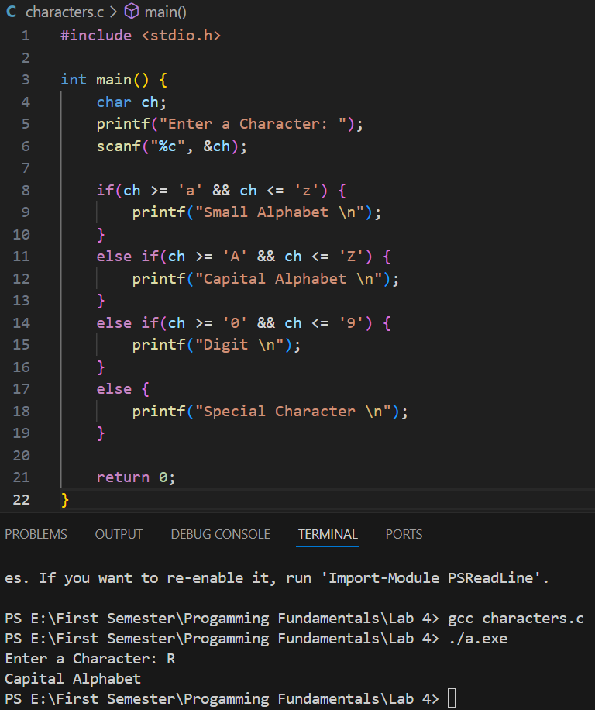

1. An online shopping store is providing discounts on the items due to the Eid. If the cost of items is more than 1999 it will give a discount up to 50%. If the cost of shopping is 2000 to 4000, a 20% discount will be applied. If the cost of shopping is 4001 to 6000, a 30% discount will be applied. If it's more than 6000 then 50% discount will be applied to the cost of shopping. Print the actual amount, saved amount and the amount after discount.

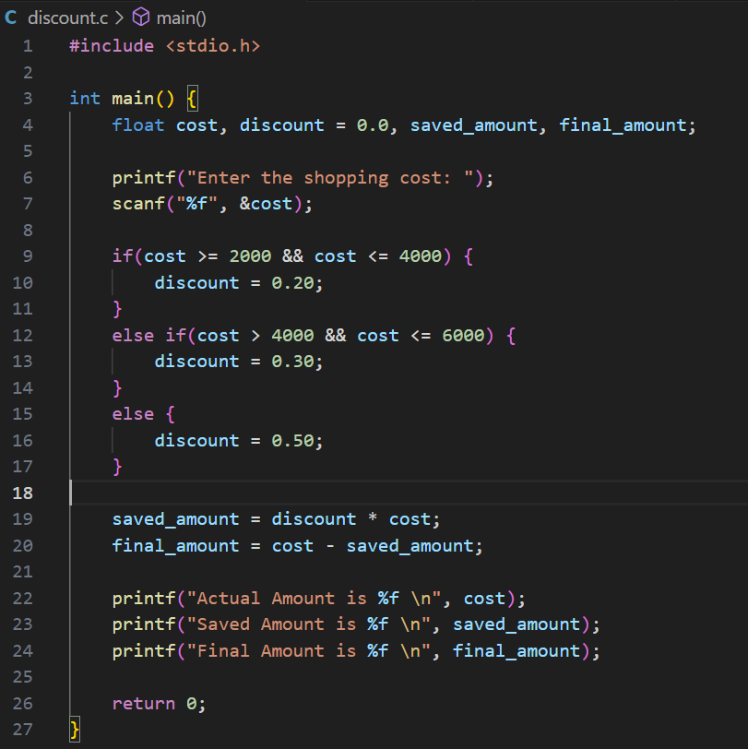

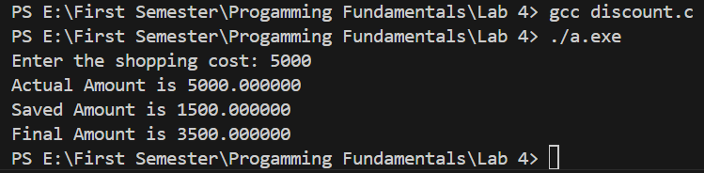

1. Write a C program to find all roots of a quadratic equation by using the quadratic formula; it is required to take user input for a, b and c values.

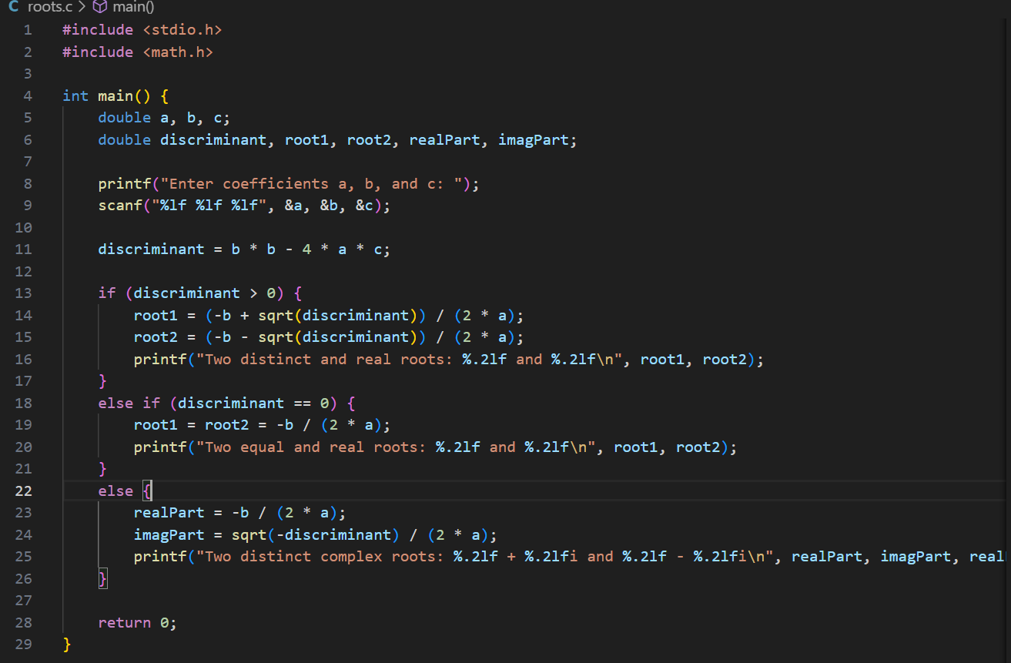

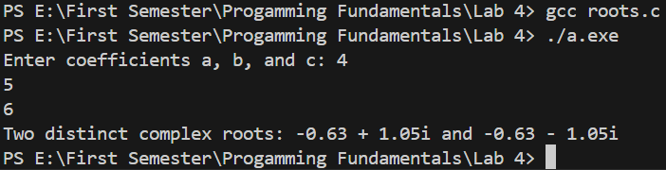

1. Teacher asks the student to check whether the input number is divisible by 7 or not. For checking the divisibility, take the last digit and double it, take the rest of the digits and subtract the doubled last digit repeat until the result is 7, -7 or 0. For example:

10976 -> 1097-12 = 1085 -> 108-10 = 98 -> 9-16 = -7

49 -> 4 - 18 = 14 -> 1 - 8 = -7

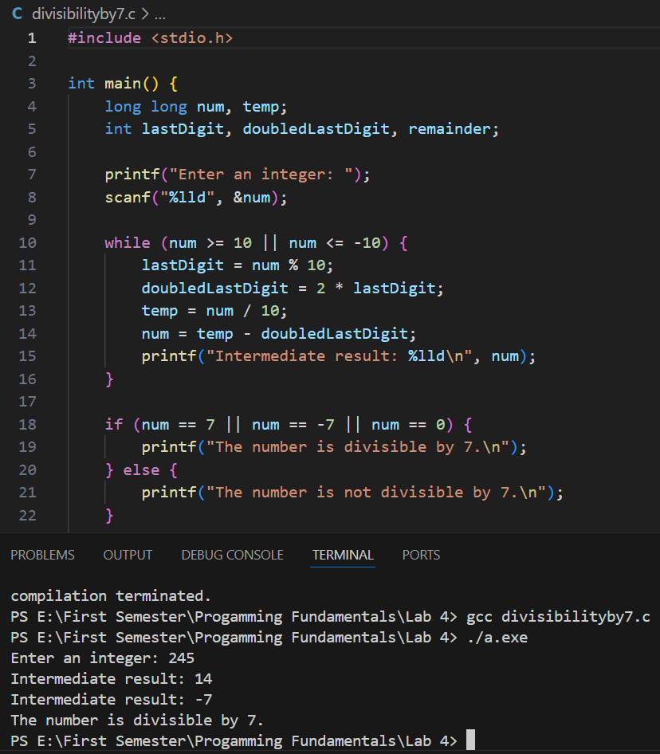

1. Write a program that asks for the number of calories and fat grams in a food. The program should display the percentage of calories that come from fat. If the calories from fat are less than 30% of the total calories of the food, it should also display a message indicating that the food is low in fat. One gram of fat has 9 calories, so Calories from fat = fat grams * 9. The percentage of calories from fat can be calculated as: calories from fat/total calories

**Input validation:** Make sure the number of calories and fat grams are not less than 0. Also, the number of calories from fat cannot be greater than the total number of calories. If that happens, display an error message indicating that either the calories or fat grams were incorrectly entered.

